INTRODUCTION

The introduction of XidML 2 in 2005 was a significant step towards providing the FTI industry with an open, extensible meta-data language for describing data transfer and storage. As with any industry, change and adaptation are necessary requirements for success, and the XidML standard is not exempt from this process. Incorporating refinements intended to better meet the needs of the FTI community as well as valuable recommendations from our members, the release of XidML 3.0 promises to make life simpler, quicker and more intuitive for FTI users by introducing the following concepts

- A Single Instrument Schema
- XDefML
- Nesting Of Instruments
- Instantiation and Referencing
- Nesting of Parameters
- Simplification of the Link Schema
- Simplification of the Parameter Schema
- Auxiliary Files
- Enumeration

A brief description of each of these concepts is contained below.

1 A SINGLE INSTRUMENT SCHEMA

XidML 2.4 had approximately 40 instrument schemas. This had two major disadvantages:

- It made integrating new types of instruments(or adding a setting to an existing instrument schema) difficult as even the most trivial change to a schema required new software support.
- It made processing of XidML files by software more complex. For example, it made automated generation of user interfaces for editing settings highly specific and less generic, thus requiring significant maintenance effort.

This problem is overcome by defining all settings using name-value pairs in a single instrument schema. This approach provides users greater flexibility for creating new, or modifying existing instruments and leads to a consistency of definition across all classes of instrument.

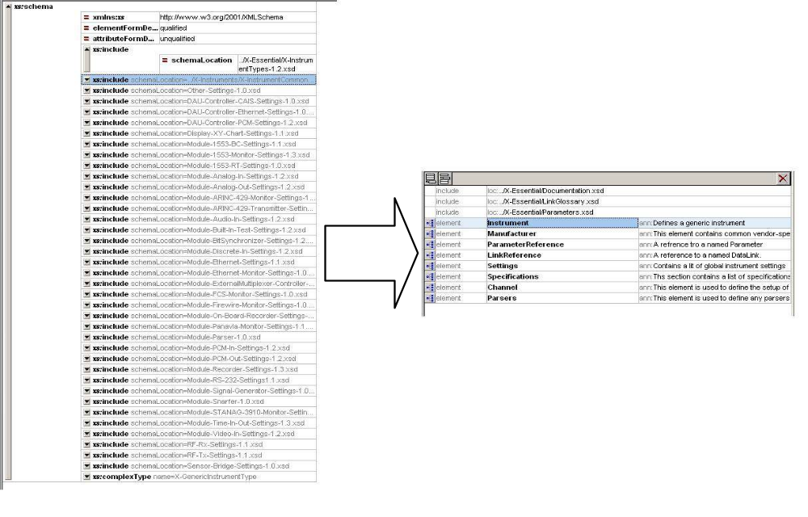

- XDEFML

The benefit of using a single, highly generic instrument schema comes at a cost. It makes comprehensive validation using an XML schema impossible.

To overcome this problem a complimentary (but optional) schema, called XdefML, was developed. This mechanism allows vendors, (or anybody else for that matter) to describe instrument specific validation constraints.

Vendors need simply write an XdefML file for each class of device they produce. Annotation, for settings, in addition to other useful information related to the device can also be included. All annotations may be localised (to other languages) if desired.

Since the single instrument schema in XidML allows for a consistent way of describing instrument configuration, XdefML allows validation constraints to be described in a consistent way. This greatly simplifies software by facilitating the automatic extraction of validation criteria and hence the automatic validation of settings on an instrument.

3 NESTING (I) - INSTRUMENTS
XidML 3.0 supports infinite nesting of instruments
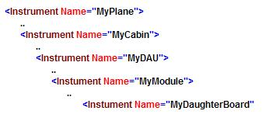
Not only does this facilitate a more natural representation of real life systems but also reflects the fact that some vendors have daughter boards or modules within modules.

4 NESTING (II) – INSTANTIATION AND REFERENCING
XidML 2.4 had a flat hierarchy, where components (Instruments, Parameters, Links, Packages) were grouped in a flat structure. For example, in a package location, a parameter would be referenced but that parameter would be defined (instantiated) only under the global parameters element.

XidML 3.0 supports the option of instantiation of components where they are referenced.

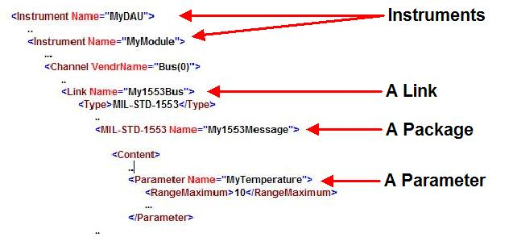
Adopting this approach, allows for a more intuitive system definition that mirrors real world systems.

5 NESTING (III) – PARAMETERS WITHIN PARAMETERS
XidML 3.0 supports any number of parameters referenced or instantiated within another parameter

Bit 0
Bit 47

MyTime

0
16
32
15
31
47

MyHiTime
MyLoTime
MyMicroTime

0
15
MyCentisecs

6 THE LINK SCHEMA

6.1 In XidML 3.0 this component name has changed from DataLink to Link to emphasise that it can be used to connect simple analog signals, power, recorder media as well as busses and networks.

6.2 In XidML 2.4 all settings common to both transmitters and receivers were defined in the Link. For example, it was thought that an ARINC-429 transmitter and receiver should both use the same setting for speed and that this should be in one place only. However, this resulted in a quite cluttered schema for the Link.

6.3 In XidML 3.0 Instrument schemas have specific channel elements in which Links are referenced or instantiated.

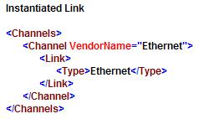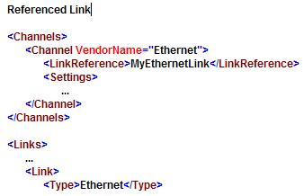

6.4 In XidML 3.0 settings for the link can be set in any instrument connected to the link and a LinkWide attribute used to indicate to validators that the value is to be used for any instrument connected to the Link.

Alternatively, these settings can be defined in a settings element in the link exactly as if they were set in the settings element of the instrument.

This results in much simpler Link schema than before, and allows users to add new settings as they see fit using XdefML

7 THE PARAMETER SCHEMA

7.1 Shunt and balance elements have been removed from the parameter component and now can be settings in the appropriate channel of the appropriate instrument.

This simplifies the parameter schema and allows vendors more flexibility in terms of the type of balancing and shunting their equipment supports.

7.2 The source and destination and transport elements have been removed from the parameter schema.

With the addition of a direction attribute in XdefML the source can be inferred.

This greatly simplifies the parameter schema.

7.3 In XidML 3.0, Parameter Types have been removed and replaced with reusable parameter units. Parameter Units can be used to create user-defined units (e.g. ft, lbs and so on).

This also simplifies the parameter schema.
8 REUSE OF AUXILIARY FILES

XidML 3.0 facilitates the reuse of auxiliary files with unique name spaces.

Imagine an engine manufacturer has an ARINC-429 bus definition for the engine they produce. If there are four identical engines with the same bus definition XidML 3.0 now allows a single auxiliary file to be used. This is achieved by associating a prefix with each engine. The prefix ensures that all referenced Parameters, Links and so on can be both uniquely identified and processed separately for each engine.

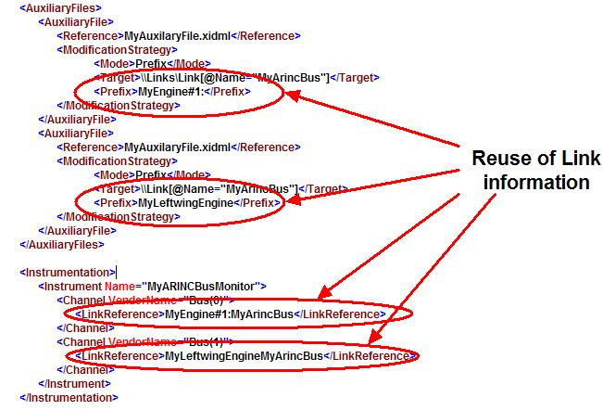

9 ENUMERATION

XidML 3.0 includes an additional algorithm for enumerated types. These algorithms can also be re-used many times in Parameter definitions.

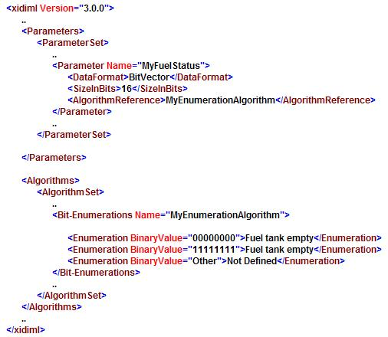

Conclusion
The changes proposed for XidML 3.0 are a significant milestone in achieving an open, accepted, extensible meta-data language for describing data transfer and storage. Refining the previous XidML 2.41 schema definition by

- Simplifying the Instrument Schema
- Introducing XdefML for validation
- Instantiating or Referencing Components
- Simplifying the Link Schema
- Simplifying the Parameter Schema
- Reusing Auxiliary Files
- Enumeration

Make XidML 3.0 an even more powerful tool for FTI users for the foreseeable future.

