Contents
1 Contents 1
2 Purpose 2
3 Launching XdefML Assistant 2
4 Strain Gauge Creation 4
4.1 Instrument Setup 4
4.1.1 Identification 4
4.1.2 Descriptions 4
4.1.3 Instrument Specifications 5
4.1.4 Classification 5
4.2 Specifications 7
4.3 Channels 10
5 Pressure Sensor Creation in XdefML Assistant 13
5.1 Instrument Setup 14
5.2 Specifications 14
5.3 Channels 15
5.3.1 Pressure Channels 15
5.3.1.1 Pressure Channel Parameter 17
Properties 18
5.3.1.1.1 18
5.3.2 Temperature Channels 22
5.3.3 Ethernet Channel 23
5.3.3.1 Ethernet Port Speed Setting 23
5.3.4 RS-422 Channel 27
5.3.4.1 RS-422 Channel Settings 27
5.3.4.1.1 RS-422 Enable 27
5.3.4.1.2 RS-422 Baud Rate 29
5.4 Parameters 32
5.4.1 Sub-Parameters 34

Figure 1 – Creating new XdefML file 3
Figure 2 - Default XdefML instrument 3
Figure 3 - Data field error 4
Figure 4 - Baseline template XdefML and schema correspondence 4
Figure 5 - Identification section completed for strain gauge 5
Figure 6 - Adding a description field 5
Figure 7 – Strain gauge description 6
Figure 8 – Strain gauge instrument specifications 6
Figure 9 – Strain gauge classification 6
Figure 10 – Completed instrument specifications and instrument identification 7
Figure 11 - Partial XdefML file for the strain gauge 7
Figure 12 - Adding a specification 8
Figure 13 - Adding a custom specification 8
Figure 14 - Adding the specification value 9
Figure 15 - XdefML file specification 9
Figure 16 – Completed Specifications 10
Figure 17 - Completed specifications in XdefML 10
Figure 18 – Basic Analog channel 11
Figure 19 - Basic Analog channel in XdefML 12
Figure 20 - Completed strain gauge output Channel 12
Figure 21 - Completed channel definition in XdefML 13
Figure 22 – Pressure scanner Instrument Setup 15
Figure 23 - Pressure scanner Specifications 15
Figure 24 - Basic pressure Channel 16
Figure 25 - Complete pressure channels 16
Figure 26 – Complete pressure channels in XdefML 17
Figure 27 - Adding a Parameter to a channel 18
Figure 28 - Basic parameter added to channel 18
Figure 29 - Basic parameter in XdefML 19
Figure 30 - Parameter properties 20
Figure 31 - Selecting the appropriate parameter base unit 20
Figure 32 - Defining the parameter bit size 21
Figure 33 - Defining the minimum range of the parameter 21
Figure 34 - Defining the parameter scaling factor 21
Figure 35 - Complete pressure parameter properties 22
Figure 36 - Complete pressure parameter in XdefML 22
Figure 37 - Complete temperature channels 23
Figure 38 - Complete temperature channels in XdefML 23
Figure 39 – Basic Ethernet channel 24
Figure 40 - Basic Ethernet channel in XdefML 24
Figure 41 - Ethernet Port Speed fixed setting 24
Figure 42 - Ethernet Port Speed fixed setting in XdefML 25
Figure 43 - Adding multiple values to Port Speed Setting 25
Figure 44 - Complete Port Speed setting 26
Figure 45 - Complete Port Speed setting in XdefML 27
Figure 46 – Basic RS-422 channel 28
Figure 47 - Basic RS-422 channel in XdefML 28
Figure 48 – Complete Enable setting 28
Figure 49 - Complete Enable setting in XdefML 29
Figure 50 - Baud Rate setting with first set of values 30
Figure 51 - Baud Rate setting with first set of values in XdefML 30
Figure 52 – Baud rate setting with second set of values 31
Figure 53 - Baud Rate setting with second set of values in XdefML 31
Figure 54 - Complete RS-422 channel in XdefML 32
Figure 55 - Basic Status parameter 33
Figure 56 - Basic Status parameter in XdefML 34
Figure 57 - Adding a sub-parameter 35
Figure 58 – Sub-parameter name and location 35
Figure 59 - Sub-parameter size 36
Figure 60 - Basic sub-parameter in XdefML 36
Figure 61 - Sub-parameter RS-422 Status 37
Figure 62 - Adding sub-parameter enumerations 37
Figure 63 - Enumerated sub-parameter in XdefML 38

Purpose
XdefML is a standard published by xidml.org which is intended to allow inter-operability between hardware devices supplied by different vendors.

This document is an introduction to the creation of hardware devices in XdefML: it is neither a comprehensive guide to the XdefML schema nor is it a definitive guide on how to define hardware in XdefML. XdefML is intended for collaboration between all stakeholders in a Flight Test Instrumentation system, therefore all stakeholders need to agree on certain facets of the XdefML description. Curtiss-Wright are the authors of this document, but Curtiss-Wright do not supply sensors: the example devices described in this document were engineered to explore the schema as much as possible rather than to reflect actual real world sensors.

Two example devices (strain gauge and pressure scanner) will be built up in XdefML using the Curtiss-Wright supplied XdefML Assistant: the advantage of using XdefML Assistant is that it provides a graphical interface to device creation, the disadvantage of using XdefML Assistant is that certain features are tailored towards Curtiss-Wright hardware and are not applicable to third-party devices. As functionality is added in XdefML Assistant, the corresponding XdefML file snippets will be provided to illustrate the connection between XdefML Assistant, the schema and the resulting XdefML file. To this end, the document should be used in conjunction with a schema viewer.

Launching XdefML Assistant
The first step after starting XdefML Assistant is to create a new file (Figure 1).

Figure 1 – Creating new XdefML file

Upon creation of a new file the default instrument template is displayed (Figure 2).

Figure 2 - Default XdefML instrument

The left pane displays a device tree which breaks down the device in a logical manner. Locations and Processes are Curtiss-Wright specific and will not be discussed further. Specifications, Channels and Parameters will be covered in a sequential manner as the sample sensors are created.

The right-hand pane displays a number of fields that give a high-level description of the device; the majority of the fields are only relevant for devices manufactured by Curtiss-Wright and can be left blank.

Most text fields throughout XdefML Assistant allow the entry of alphanumeric characters and special symbols; where a field does have a constraint on the data allowed and the incorrect data is entered, a context error similar to Figure 3 will be displayed.

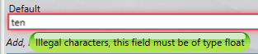
Figure 3 - Data field error

The remainder of this document will step through the creation of the two sample sensors in turn; initially the Instrument Setup is defined, then each of the relevant logical functions from the device tree will be configured.

The actual contents of the XdefML file for the default template and how it corresponds to the schema is illustrated in Figure 4.

Figure 4 - Baseline template XdefML and schema correspondence

The correspondence between the XdefML elements and the schema is mostly self-explanatory. Dotted boxes in the schema representation in Figure 4 indicate that the element is optional, so, for example, the SlotsOccupied element can be removed from the text file.

This type of diagram will be used throughout this document to try and draw the connection between the schema and the resulting XdefML.

Strain Gauge
The first device to be created is the strain gauge: the relevant details for this sensor are given in Table 1.

Specification | Value
Manufacturer | Beta
Part No. | BFS-4/350-FB18
Nominal Resistance (Ω) | 350
Maximum Excitation (Vpp) | 18
Temperature Compensation | Steel
Grid Height (mm) | 1.8
Grid Width (mm) | 2.0
Table 1 - Strain gauge specifications

Instrument Setup
This section of XdefML Assistant is where the high level characteristics of the sensor are defined. The majority of these fields are Curtiss-Wright specific and are not applicable to third-party devices. Section 4.1.1 through Section 4.1.4 describe the fields further.

Identification
This section is primarily concerned with the device manufacturer and part number, i.e. enough information to identify a device type.

Field | Description | CW Specific | Required
Manufacturer Name | The manufacturer of the device | No | Yes
Part Reference | The device part number | No | Yes
Manufacturer ID | Alternative part number | No | No
Model Reference | Alternative part number | No | No
Sample Serial Number | Format of device serial number | No | No
Sample Instrument Name | Alternative part number | No | No
Table 2 - Identification Section

Figure 5 illustrates the identification section completed for the strain gauge.

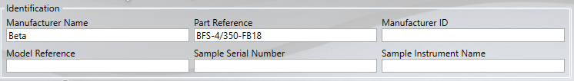
Figure 5 - Identification section completed for strain gauge

Descriptions
Many properties in XdefML have optional descriptions: they are always added as shown in Figure 6.
Figure 6 - Adding a description field
Figure 7 is an example of a high-level description for the sensor.

Figure 7 – Strain gauge description

Instrument Specifications
This section specifies whether the device needs a parent device to function, or whether the device is standalone: all third-party devices are classified as standalone.

Field | Description | CW Specific | Required
Slots Occupied | The number of slots occupied by the device – this is only relevant for CW devices | Yes | No
Associated Icon | The icon file used to represent the device – this is only relevant for CW devices | Yes | No
Is Standalone | Is the device used as part of a bigger CW system – all third party devices will be standalone | No | Yes
Datasheet URL | The device datasheet | No | No
Table 3 – Instrument specifications section

Figure 8 shows the Is Standalone switch set to “ON” for the standalone strain gauge.

Figure 8 – Strain gauge instrument specifications

Classification
This section describes the device family and how the device should interact with a larger system: the values specified here should agree with those of the larger system to ensure interoperability.

Field | Description | CW Specific | Required
Functional Classes | This specific sensor’s function | Yes | Yes
Mechanical Class | The sensor family | Yes | Yes
Table 4 - Classification section

Figure 9 illustrates an example classifications section for the strain gauge.

Figure 9 – Strain gauge classification

Figure 10 gives the completed Instrument Setup window for the strain gauge: Figure 11 shows how this is expressed in XdefML.

Figure 10 – Completed instrument specifications and instrument identification

Figure 11 - Partial XdefML file for the strain gauge

Specifications
This section is used to capture the sensor’s physical characteristics or constants; e.g. mass, dimensions, resistance, etc.

Figure 12 and Figure 13 illustrate how to add a Specification in XdefML Assistant from the device tree. Channels and Parameters are added in the same fashion: i.e. right click on the relevant folder and add the required function.

Figure 12 - Adding a specification

A Dictionary window will be displayed as shown in Figure 13. In this case the Dictionary displays Specifications; Dictionaries are encountered throughout XdefML Assistant and can contain Specifications, Settings, Parameters, etc. Throughout this document the user will be instructed to “Create your own” field: the reason for this is that the existing entries in the different Dictionaries are too restrictive for general use.

Figure 13 – Specification dictionary

Enter the specification value and an optional description as shown in Figure 14.

Figure 14 - Adding a specification value

Figure 15 gives the XdefML snippet for the specification.

Figure 15 – Specification in XdefML

The remainder of the specifications from Table 1 are added in a similar fashion (Figure 16 and Figure 17).

Figure 16 – Completed specifications

Figure 17 - Completed specifications in XdefML

Channels
The strain gauge (in common with all sensors) needs to be physically connected to another device to be of use. This is achieved in XdefML through the concept of a channel. A sensor (or any other device type) can have any number of different channel types. Each channel type in turn can have any number of physical channels which can be input, output or bidirectional.

The channel type specified influences how the device interacts with a larger system: the value(s) specified should agree with those of complementary devices in the larger system to ensure interoperability.

The strain gauge can be modelled as having one output channel with a channel type of Analog. Following the general procedure for adding a specification (Section 4.2, Figure 12 and Figure 13), a channel of type Analog can be added as illustrated in Figure 18.

Figure 18 – Basic Analog channel

The corresponding XdefML file snippet together with the relevant section of the schema is shown in Figure 19.

Figure 19 - Basic Analog channel in XdefML

The Number attribute can be left blank as there is only one strain gauge channel to be defined. The Direction attribute must be modified to reflect that strain information flows out from the gauge. The Base Name attribute can be modified to give a more meaningful channel name. Finally an optional description for the channel can be added. The result of these changes is illustrated in Figure 20.

Figure 20 - Completed strain gauge output Channel

Figure 21 gives the corresponding XdefML snippet where the Number attribute has been explicitly set.

Figure 21 - Completed channel definition in XdefML

This completes the XdefML definition of the strain gauge.

Pressure Sensor
The next device to be created is the pressure scanner: the relevant specifications and functionality is detailed below.

Specification | Value | Comments
Manufacturer | Hotrong
Part No. | HrPS-1-64-E
Number of pressure channels | 64
Pressure channel resolution (bits) | 24 | 0x000000 represents 5kPa  0xFFFFFF represents 5500kPa
Pressure Range (kPa) | 5 to 5500
Maximum Excitation (VDC) | 32
Minimum Excitation (VDC) | 12
Number of temperature channels | 8
Temperature channel resolution | 16 | Twos complement value
Temperature Range (°C) | -55 to 120
Sensor Height (mm) | 240
Sensor Length (mm) | 105
Sensor Width (mm) | 75
Sensor Mass (kg) | 1.587
Table 5 - Pressure scanner specifications

The pressure and temperature data from the sensor can be read either over Ethernet or RS-422 – the user sends a command over either interface to read the relevant pressure/temperature channel.

The Ethernet output can be configured for 10Mbps or 100Mbps.

The RS-422 interface can be configured for 19.2kbps, 38.4kbps or 57.6kbps. The RS-422 interface can also be disabled to save power consumption.

The scanner has one 16-bit Status register which reports the global status of the scanner; Table 6 give the bitmap.

Bit(s) | Description
15 through 5 | Reserved
4 through 3 | RS-422 Status  00 – RS-422 disabled  01 – 19200bps baud rate  10 – 38400bps baud rate  11 – 57600bps baud rate
2 | Reserved
1 through 0 | Scanner Health  00 – Scanner temperature exceeds 120C  01 – Scanner temperature below -55C  10 – Reserved  11 – Scanner functioning ok
Table 6 - Pressure scanner Status register

Instrument Setup
The Instrument Setup follows the general procedure of Section 4.1: Figure 18 illustrates the result.

Figure 22 – Pressure scanner Instrument Setup

Specifications
The Specifications for the pressure scanner are added in the same manner as Section 4.2. The completed specifications are shown in Figure 23.

Figure 23 - Pressure scanner Specifications

Channels
The pressure scanner has multiple Channel Types: some channels output pressure and temperature data, while other channels are used to enable communication with other devices. Therefore, it is sensible to sub-divide the Channel Types; Analog for pressure and temperature, Ethernet for the Ethernet interface and Serial for the RS-422 interface. As mentioned before, these Channel Types should match those of other devices to ensure interoperability.

Pressure Channels
Adding a channel as described in Section 0 results in the window shown in Figure 24.

Figure 24 - Basic pressure Channel

The fields must be modified to set the channel as an output with an Analog type; they must also be modified to account for the 64 pressure channels which should be named Pressure(0), Pressure(1)…Pressure(63). This is achieved in Figure 25 using a naming strategy: Start Index always defaults to 0, while Increment always defaults to 1. The corresponding XdefML snippet (Figure 26) has the StartIndex and Increment attributes defined explicitly.

Figure 25 - Complete pressure channels
Figure 26 – Complete pressure channels in XdefML

Pressure Channel Parameter
The output from each channel is in a digital format as described in Table 5. This can be defined in XdefML by adding a parameter to each channel: this is done by expanding the pressure channel as shown in Figure 27 and then following the general procedure of Section 4.2.

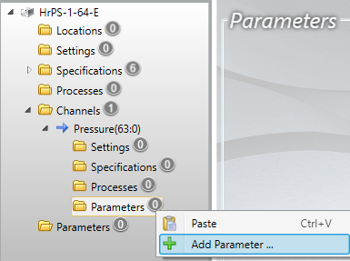
Figure 27 - Adding a Parameter to a channel

Choosing a parameter name of “pressure-reading” results in the window shown in Figure 28.

Figure 28 - Basic parameter added to channel

Properties
The XdefML snippet for the parameter is shown in Figure 29.

Figure 29 - Basic parameter in XdefML

The parameter properties (data format, range, units, etc.) are defined in the Parameter Properties tab illustrated in Figure 30.

Figure 30 - Parameter properties

The first three properties listed (Base Unit, Data Format, Size In Bits) are mandatory, the remainder are optional and are only defined if required for the particular device.

Expanding the Base Unit property allows the appropriate unit to be selected as shown in Figure 31.

Figure 31 - Selecting the appropriate parameter base unit

The Data Format property reflects the binary format of the parameter data. The pressure parameter is OffsetBinary and is set in the same manner as the Base Unit property.

Expanding the Size In Bits property allows the parameter bit size to be defined as shown in Figure 32.

Figure 32 - Defining the parameter bit size

The minimum range for the parameter is defined as shown in Figure 33. The maximum range for the parameter is defined in a similar fashion.

Figure 33 - Defining the minimum range of the parameter

The base unit has been defined as Pascals, however the actual measurement units are kPa. Therefore the parameter scale (1e-3) property should be set (Figure 34). The unit property is set in a similar way.

Figure 34 - Defining the parameter scaling factor

Figure 35 summarises the parameter properties; Figure 36 gives the XdefML snippet for the completed parameter.

Figure 35 - Complete pressure parameter properties

Figure 36 - Complete pressure parameter in XdefML

Temperature Channels
The scanner temperature channels and parameters are added in the same way as the pressure channels and parameters with provision made for the different number of channels and data structure (Figure 37 and Figure 38).

Figure 37 - Complete temperature channels

Figure 38 - Complete temperature channels in XdefML

Ethernet Channel
The scanner Ethernet connection is bi-directional (commands are sent to the scanner and responses are sent from the scanner) and is given a Channel Type of Ethernet.

Adding a channel with these properties results in Figure 39 and the corresponding XdefML snippet of Figure 40.

Figure 39 – Basic Ethernet channel

Figure 40 - Basic Ethernet channel in XdefML

Ethernet Port Speed Setting
The scanner Ethernet connection speed can have multiple values (10Mbps or 100Mbps): additionally, whichever value is selected must match that of the Ethernet connection of any connected device. This can be modelled in XdefML by adding a Setting under the Channel in the same manner that a Parameter was added to a Channel (Section 0, Figure 27), and then following the steps in Figure 41. Note that if Link Wide is selected, the Setting Name and Setting Value(s) should match that of comparable Settings in the wider system to ensure inter-operability.

Figure 41 - Ethernet Port Speed fixed setting

Figure 42 - Ethernet Port Speed fixed setting in XdefML

Adding further selections displays the window shown in Figure 43.

Figure 43 - Adding multiple values to Port Speed Setting

The complete Port Speed setting now allows for a choice between two distinct values (Figure 44 and Figure 45).

Figure 44 - Complete Port Speed setting
Figure 45 - Complete Port Speed setting in XdefML

RS-422 Channel
The RS-422 channel (Figure 46 and Figure 47) is added in the same way as the Ethernet channel.

Figure 46 – Basic RS-422 channel

Figure 47 - Basic RS-422 channel in XdefML

RS-422 Channel Settings
The RS-422 channel has two settings; an Enable setting which turns the channel on or off and a Link Wide Baud Rate setting with multiple values (19200, 38400, 57600bps). The Baud Rate setting values depend on the Enable setting value: if Enable is false, then the Baud Rate value should be “N/A”.

RS-422 Enable
This setting is added in the same manner as the Ethernet Port Speed (Section 5.3.3.1). To make the setting have a dependent the Propagation property is set to true (Figure 48 and Figure 49).

Figure 48 – Complete Enable setting

Figure 49 - Complete Enable setting in XdefML

RS-422 Baud Rate
This setting can have two possible sets of values depending on the value of the Enable setting. Figure 50 and Figure 51 show the Baud Rate setting with the first set of values added.

Figure 50 - Baud Rate setting with first set of values

Figure 51 - Baud Rate setting with first set of values in XdefML

Figure 52 and Figure 53 describe how to add the dependency on Enable to the Baud Rate values.

Figure 52 – Baud rate setting with second set of values

Figure 53 - Baud Rate setting with second set of values in XdefML

Figure 54 shows the complete XdefML representation of the RS-422 channel.

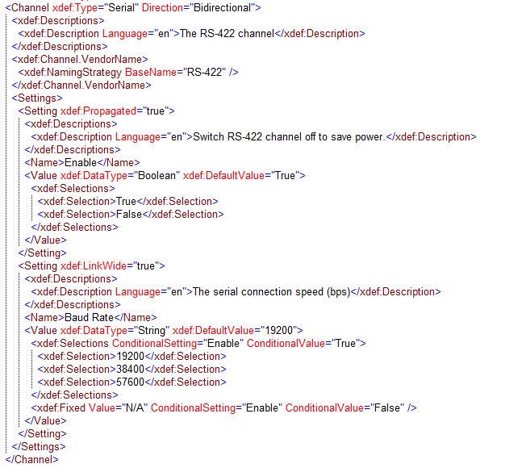
Figure 54 - Complete RS-422 channel in XdefML

Parameters
The scanner has one global status register or parameter. This parameter is modelled in the same fashion as that of Section 0, the only difference being it is created on the root of the device tree (Figure 55 and Figure 56).

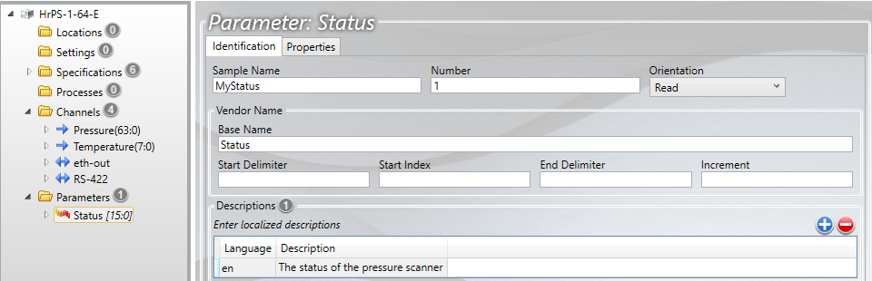
Figure 55 - Basic Status parameter
Figure 56 - Basic Status parameter in XdefML

Sub-Parameters
Table 6 defines a bitmapping for the Status register: this is modelled in XdefML by adding sub-parameters to the parent parameter (Figure 57).

Figure 57 - Adding a sub-parameter

Adding the first entry from Table 6 (Reserved) is shown in Figure 58. The sub-parameter will not have it’s own name, it will instead be defined by it’s size and bit-location.

Figure 58 – Sub-parameter name and location

The sub-parameter size is set under the Properties tab (Figure 59).

Figure 59 - Sub-parameter size

Figure 60 displays the sub-parameter in XdefML.

Figure 60 - Basic sub-parameter in XdefML

The next sub-parameter from Table 6 (RS-422 Status) is added in a similar fashion (Figure 61).

Figure 61 - Sub-parameter RS-422 Status

The RS-422 Status bitmap maps a string to each bitmap value. This is achieved in XdefML through enumerations as shown in Figure 62.

Figure 62 - Adding sub-parameter enumerations

Figure 63 displays the sub-parameter enumerations in XdefML.

Figure 63 - Enumerated sub-parameter in XdefML

The remaining sub-parameters are added in a similar fashion to complete the XdefML for the pressure scanner.

